Contents

Installing XAMPP 1

The XAMPP Control Panel 7

Starting modules 8

Setting up XAMPP 9

How to install NetBeans IDE 11.3 on Windows 10 10

Step 1: Download and Install Java 13 11

Step 2: Download NetBeans IDE 22

Step 3: Installing NetBeans IDE 26

Step 4: Set NetBeans and Java path 27

Step 5: Launch NetBeans after installation 31

How to install MySQL database server 8.0.19 33

Download and install MySQL database server 33

Install the sample database 49

Connect to MySQL Server 54

Installing XAMPP

Our XAMPP tutorial will take you through the installation process for the software package on Windows. If you’re using Linux or Mac OS X, then the steps listed below for the installation process may differ.

Step 1: Download

XAMPP is a release made available by the non-profit project Apache Friends. Versions with PHP 5.5, 5.6, or 7 are available for download on the [Apache Friends](http://www.apachefriends.org/de/download.html) website.

https://www.apachefriends.org/de/download.html

Step 2: Run .exe file

Once the software bundle has been downloaded, you can start the installation by double clicking on the file with the ending [.exe](https://www.ionos.com/digitalguide/server/know-how/exe-file/).

Step 3: Deactivate any antivirus software

Since an active antivirus program can negatively affect the installation process, it’s recommended to temporarily pause any antivirus software until all XAMPP components have successfully been installed.

[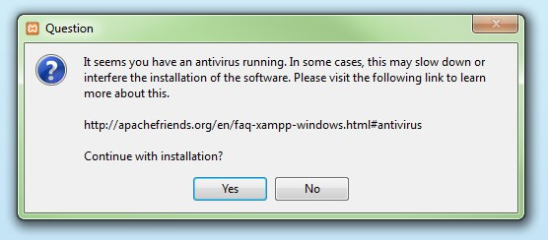](https://www.ionos.com/digitalguide/fileadmin/DigitalGuide/Screenshots/XAMPP_01.jpg)Before installing XAMPP, it is advisable to disable the anti-virus program temporarily

Step 4: Deactivate UAC

User Account Control (UAC) can interfere with the XAMPP installation because it limits writing access to the C: drive, so we recommend you deactivate this too for the duration of the installation process. To find out how to turn off your UAC, head to the [Microsoft Windows support pages](https://support.microsoft.com/en-us/help/17228/windows-protect-my-pc-from-viruses).

[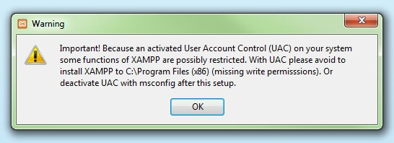](https://www.ionos.com/digitalguide/fileadmin/DigitalGuide/Screenshots/XAMPP_02.jpg)User account control can affect the installation of XAMPP

Step 5: Start the setup wizard

After you’ve opened the .exe file (after deactivating your antivirus program(s) and taken note of the User Account Control, the start screen of the XAMPP setup wizard should appear automatically. Click on ‘Next’ to configure the installation settings.

[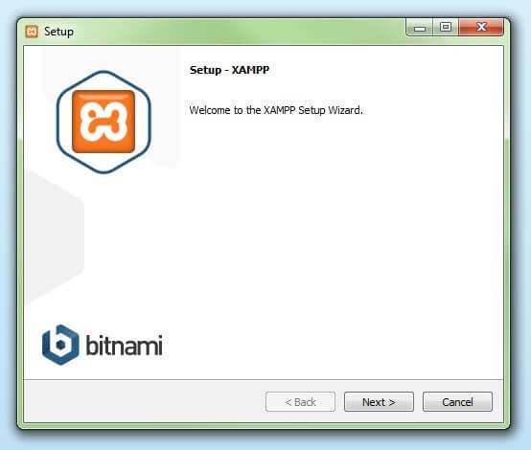](https://www.ionos.com/digitalguide/fileadmin/DigitalGuide/Screenshots/XAMPP_03.jpg)

You can start the setup on the startup screen

Step 6: Choose software components

Under ‘Select Components’, you have the option to exclude individual components of the XAMPP software bundle from the installation. But for a full local test server, we recommend you install using the standard setup and all available components. After making your choice, click ‘Next’.

[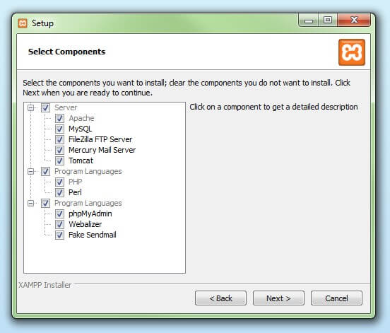](https://www.ionos.com/digitalguide/fileadmin/DigitalGuide/Screenshots/XAMPP_04.jpg)

In the dialog window entitled 'select components', you can choose the software components before installation

Step 7: Choose the installation directory

In this next step, you have the chance to choose where you’d like the XAMPP software packet to be installed. If you opt for the standard setup, then a folder with the name XAMPP will be created under C:\ for you. After you’ve chosen a location, click ‘Next’.

[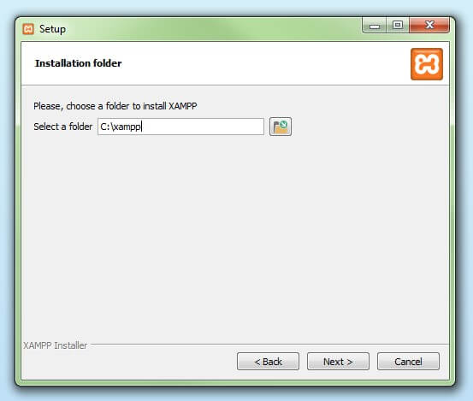](https://www.ionos.com/digitalguide/fileadmin/DigitalGuide/Screenshots/XAMPP_05.jpg)

For the next step, you need to select the directory where XAMPP should be installed

Step 8: Start the installation process

Once all the aforementioned preferences have been decided, click to start the installation. The setup wizard will unpack and install the selected components and save them to the designated directory. This process can take several minutes in total. You can follow the progress of this installation by keeping an eye on the green loading bar in the middle of the screen.

[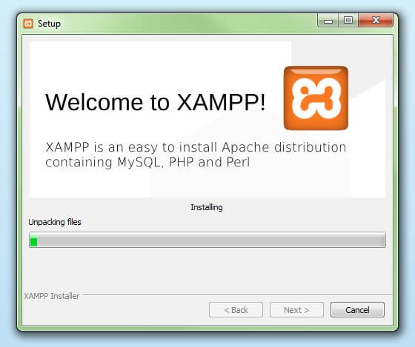](https://www.ionos.com/digitalguide/fileadmin/DigitalGuide/Screenshots/XAMPP_06.jpg)

According to the default settings, the selected software components are unpacked and installed in the target folder

Step 9: Windows Firewall blocking

Your Firewall may interrupt the installation process to block the some components of the XAMPP. Use the corresponding check box to enable communication between the Apache server and your private network or work network. Remember that making your XAMPP server available for public networks isn’t recommended.

Step 10: Complete installation

Once all the components are unpacked and installed, you can close the setup wizard by clicking on ‘Finish’. Click to tick the corresponding check box and open the XAMPP Control Panel once the installation process is finished.

[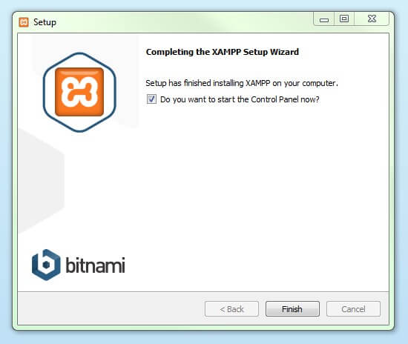](https://www.ionos.com/digitalguide/fileadmin/DigitalGuide/Screenshots/XAMPP_08.jpg)

By clicking on 'finish', the XAMPP Setup Wizard is completed

The XAMPP Control Panel

Controls for the individual components of your test server can be reached through the XAMPP Control Panel. **The clear user interface**logs all actions and allows you to start or stop individual modules with a single. The XAMPP Control Panel also offers you various other buttons, including:

* **Config:** allows you to configure the XAMPP as well as the individual components
* [Netstat](https://www.ionos.com/digitalguide/server/tools/introduction-to-netstat/)**:** shows all running processes on the local computer
* **Shell:** opens a UNIX shell
* **Explorer:** opens the XAMPP folder in Windows Explorer
* **Services:** shows all services currently running in the background
* **Help:**offers links to user forums
* **Quit:**closes the XAMPP Control Panel

[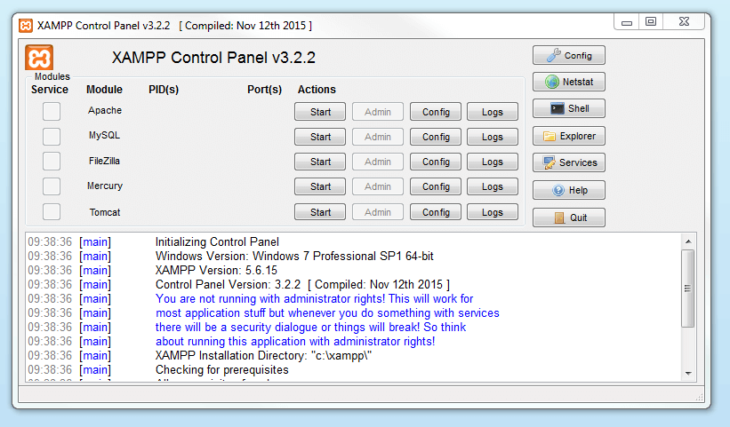](https://www.ionos.com/digitalguide/fileadmin/DigitalGuide/Screenshots/EN_XAMPP_Control_Panel_1.PNG)In the Control Panel, you can start and stop individual modules

Starting modules

Individual modules can be started or stopped on the XAMPP Control Panel through the corresponding buttons under ‘Actions’. You can see which modules have been started because their names are highlighted green under the ‘Module’ title.

[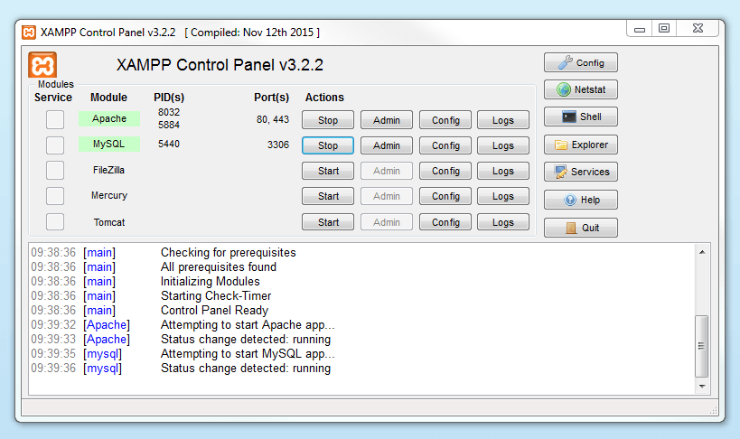](https://www.ionos.com/digitalguide/fileadmin/DigitalGuide/Screenshots/EN_XAMPP_Control_Panel_2.PNG)An active module is marked in green in the Control Panel

If a module can’t be started as a result of an error, you’ll be informed of this straight away in red font. A **detailed error report** can help you identify the cause of the issue.

Setting up XAMPP

A common source of error connected with Apache is **blocked ports**. If you’re using the standard setup, then XAMPP will assign the web server to main port 80 and the SSL port 443. The latter of these particularly is often blocked by other programs. In the example above, it’s likely that the Tomcat port is being blocked, meaning the web server can’t be started. There are three ways to solve this issue:

* **Change the conflicting port:**Let’s assume for the sake of example that the instant messenger program Skype is blocking SSL port 443 (this is a common problem). One way to deal with this issue is to change Skype’s port settings. To do this, open the program and navigate via ‘Actions’, ‘Options’, and ‘Advanced’, until you reach the ‘Connections’ menu. You should find a box checked to allow Skype access to ports 80 and 443. Deselect this checkbox now.
* **Change the XAMPP module port settings**: Click the Config button for the module in question and open the files *httpd.conf* and *httpd-ssl.conf*. Replace port number 80 in *httpd.conf* and port number 443 in *httpd-ssl.conf*with any free ports, before saving the file data. Now click on the general Config button on the right-hand side and select ‘Services and Ports Settings’. Customize the ports for the module server to reflect the changes in the *conf* files.
* **End the conflicting program:**The simplest way to avoid port conflicts in the short term is to end the conflicting program (Skype in this case). If you restart Skype after your XAMPP module servers are already running, it will select a different port and your issue will be resolved.

[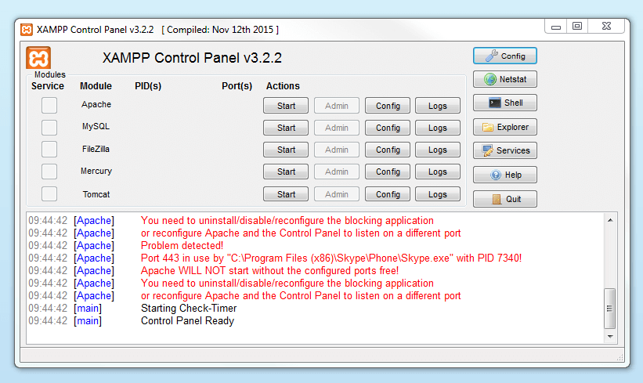](https://www.ionos.com/digitalguide/fileadmin/DigitalGuide/Screenshots/EN_XAMPP_Control_Panel_3.PNG)

## How to install NetBeans IDE 11.3 on Windows 10

NetBeans is a free and open source Integrate Development Environment (IDE) and governed by the Apache Software Foundation. Develop desktop, mobile, and web applications with Java, JavaScript, HTML5, PHP, C/C++, etc easily with NetBeans. Here, we will be installing NetBeans IDE.

In this tutorial, we will learn how to install NetBeans IDE 11.3 on Windows 10. Java installation is also necessary since NetBeans is a Java based IDE, tvideoherefore we will also see JAVA JDK 13 installation while installing NetBeans IDE with text as well as video tutorial below:

Following steps we will follow to install NetBeans IDE on Windows 10:

* Download and Install Java 13
* Download NetBeans
* Installing NetBeans IDE
* Set NetBeans and Java path
* Launch NetBeans after installation
* Check the Video Tutorial also

Let’s begin with the installation:

## Step 1: Download and Install Java 13

Java 13 released on September 17th, 2019. With that, the need of its usage is scaling high these days. In this article, we will see how to install Java JDK 13 on Windows 10 OS. With that, to avoid any hassles in future, we will also let you know how to verify the installation.

Let us now Download Java JDK 13

To download Java 13, go to [Oracle’s official website](https://www.oracle.com/index.html) and type “JAVA JDK 13” in the search box as in the below screenshot:

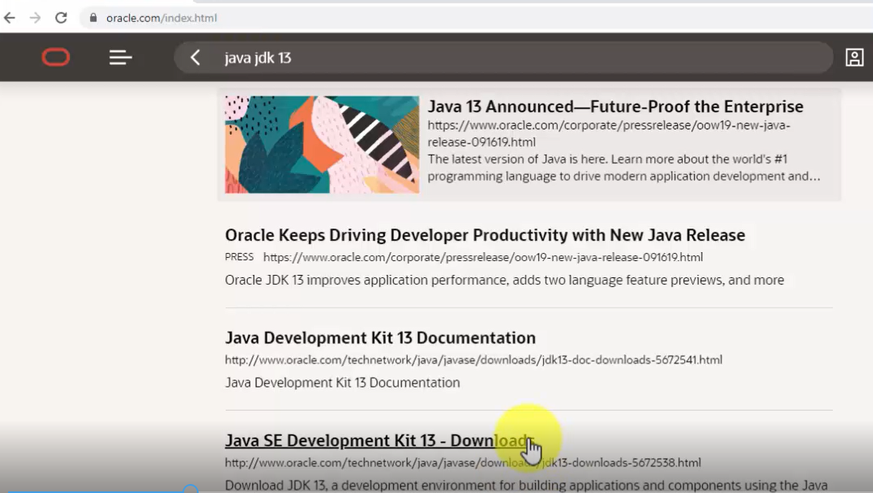

Now, click “**Java SE Development Kit 13 – Downloads**” and you will reach the **Downloads** section:

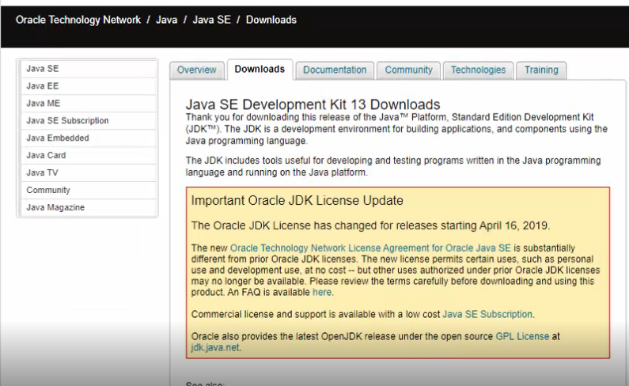

Go to bottom of the same page, click “**Accept**” there itself:

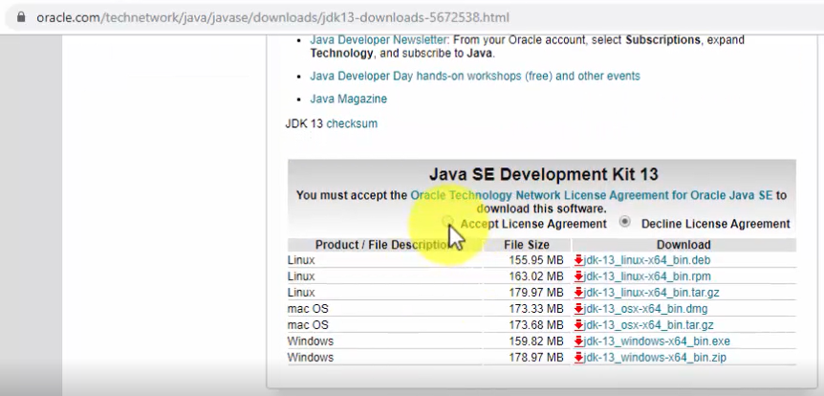

Since, we are on a Windows 10 system, therefore, we now have two options. From that, we will go with the installer exe 64-bit file i.e. **jdk-13_windows-x64_bin.exe:**

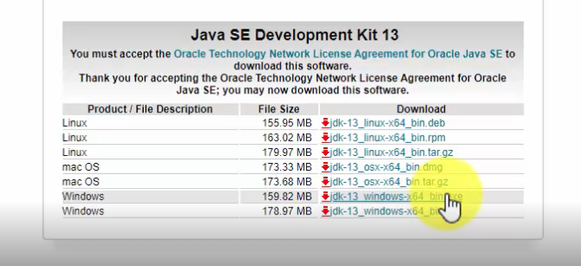

**Note**: Java JDK 13 will get installed only on a 64-bit Windows 10 system

As you can see on the bottom-left of the web browser, the download begins. Just wait for few minutes till the download finishes:

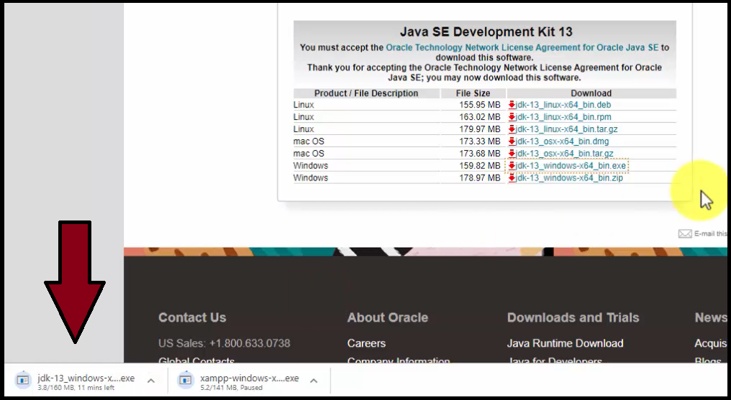

The downloaded jdk exe file will get saved in the “Downloads” folder:

Now, go to “Downloads” folder on your Windows 10 system and double click on the “**jdk-13_windows-x64_bin.exe**” file:

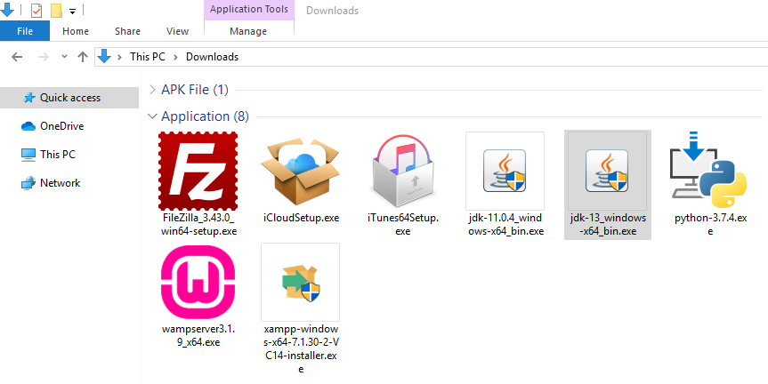

Double click on the exe file and the installation begins:

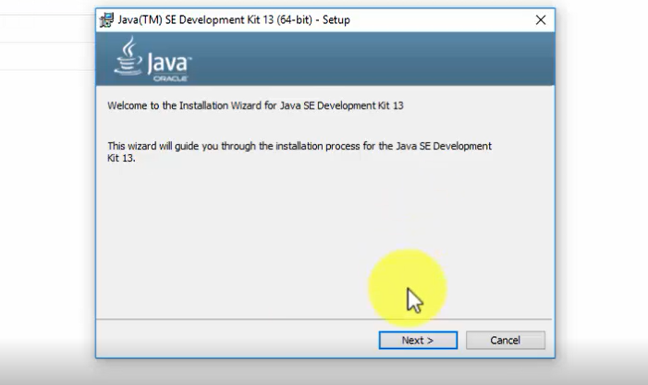

Click on “**Next**” above and set the path wherein the Java 13 will get installed. You can also keep it the default:

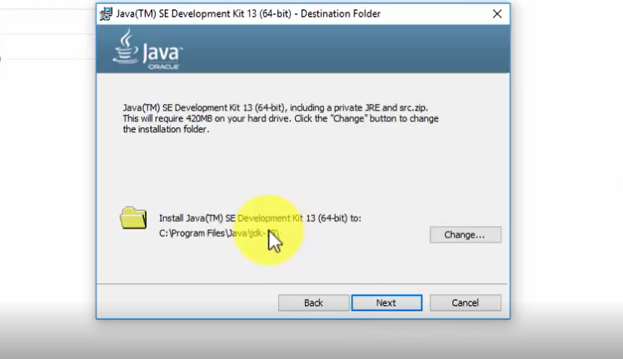

Click on “**Next**” above and the installation continues for some minutes.

The installation finishes as in the following screenshot. Click on “**Close**“:

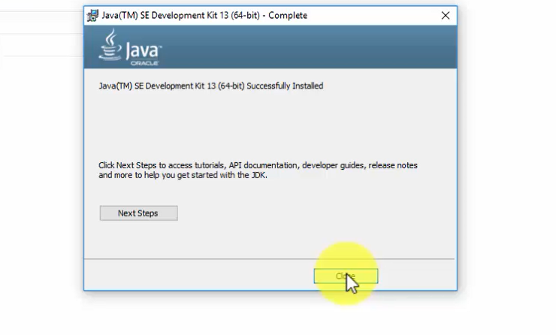

Now, let us set the JDK path.

Now, we will see how to set Java JDK Path (Environment Variable).

At first, copy the path wherein you installed the Java JDK. Let us copy it first. Remember, we need to copy the bin path i.e. the following on our system:

Here’s the screenshot of the “**bin**” path, wherein we installed Java 13:

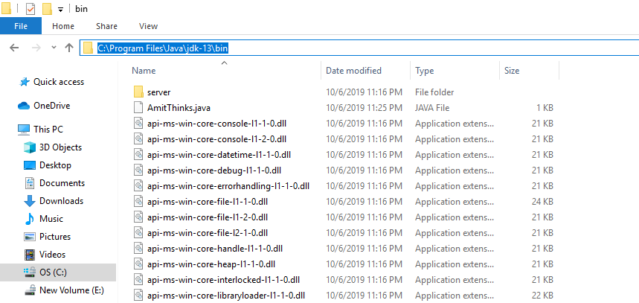

To set JDK Path, the easiest way is to type “**Environment Variables**” on **Start**. On typing, the following would be visible:

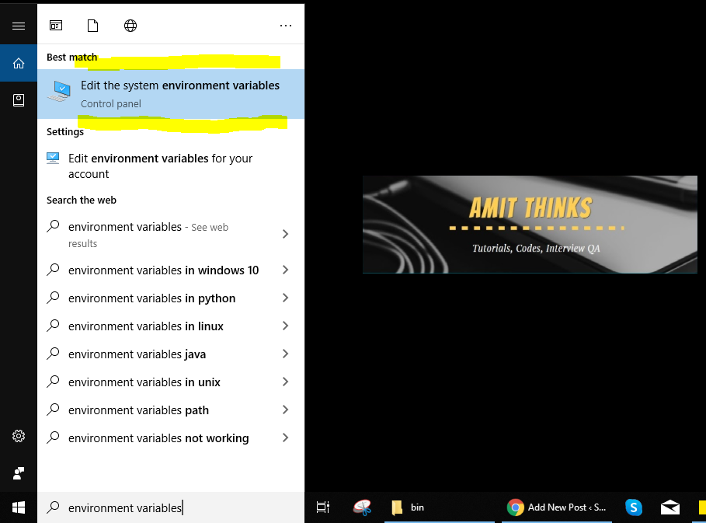

Now, click on “**Edit Environment Variables**” and a new dialog box would be visible:

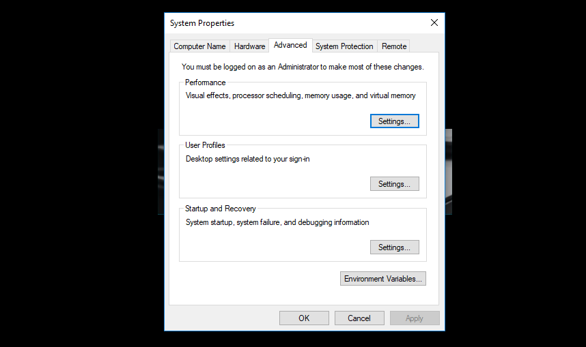

Now, click “**Environment Variable**” and a new dialog box will open. Go to “**System Variables**” section and double click “**Path**” as in the below screenshot:

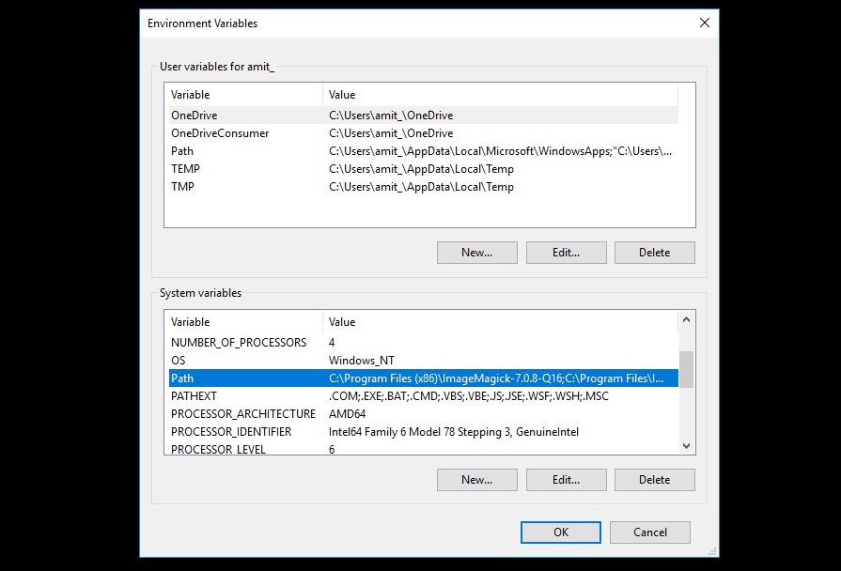

On clicking “**Path**“, a new dialog box will open. From there, click “**New**” and add the Java JDK path “**C:\Program Files\Java\jdk-13\bin**” as displayed in the below screenshot:

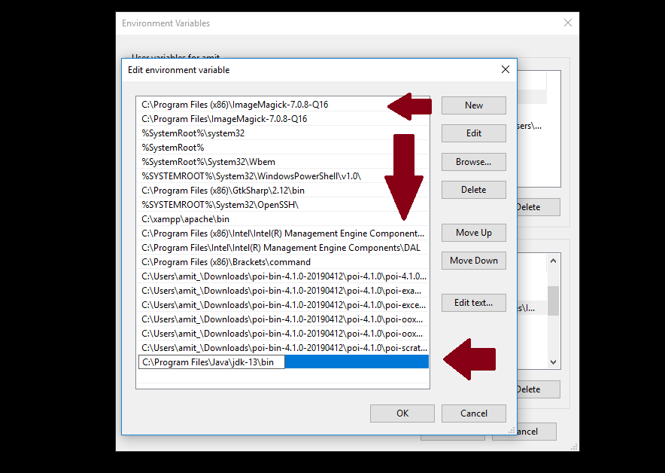

Above, press Ok for all the dialog boxes i.e. 3 times. This ends the installation and the procedure to set path for JDK. Now, we will verify the JDK installation.

Now, we will verify Java JDK 13 Installation.

We saw how to install Java JDK 13 above. We installed on Windows 10 OS. Now, we can easily verify whether the installation was successfully or not using the following command:

Let us implement the above command on command prompt (cmd) and verify Java installation:

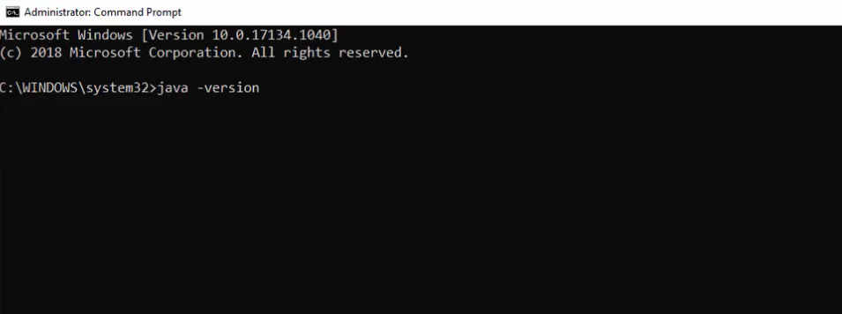

Therefore, the installation verification is now complete and successful since now we can see the version in the command prompt:

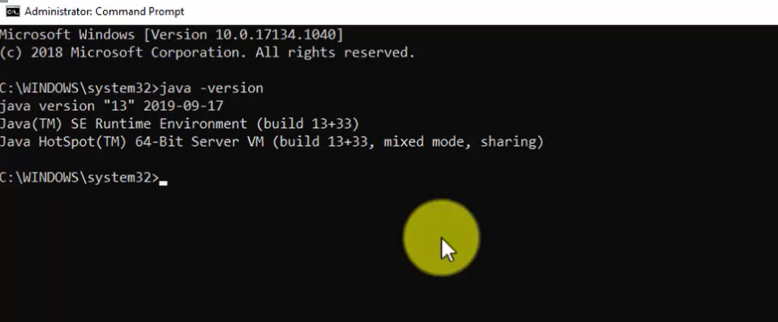

If you’d like to watching a video for installing Java 13 on Windows 10:

## Step 2: Download NetBeans IDE

We installed Java above for NetBeans. Now, to install NetBeans IDE on Windows 10, at first we will download NetBeans IDE.

Go to Google and type **Download NetBeans IDE 11.3.**On typing, the official website of NetBeans i.e. **“netbeans.apache.org”**would be visible on the top of search results. Click on the website to download NetBeans as in the below screenshot:

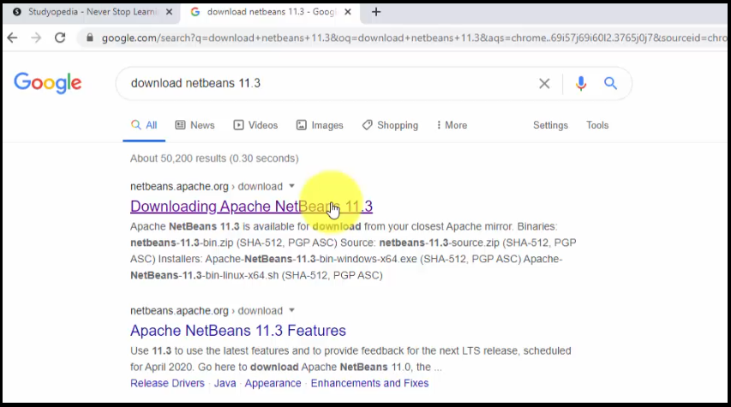

Now, the official website will open. Click on the Windows exe file i.e.**“Apache-NetBeans-11.3-bin-windows-x64”** file since we have to install NetBeans IDE on Windows 10:

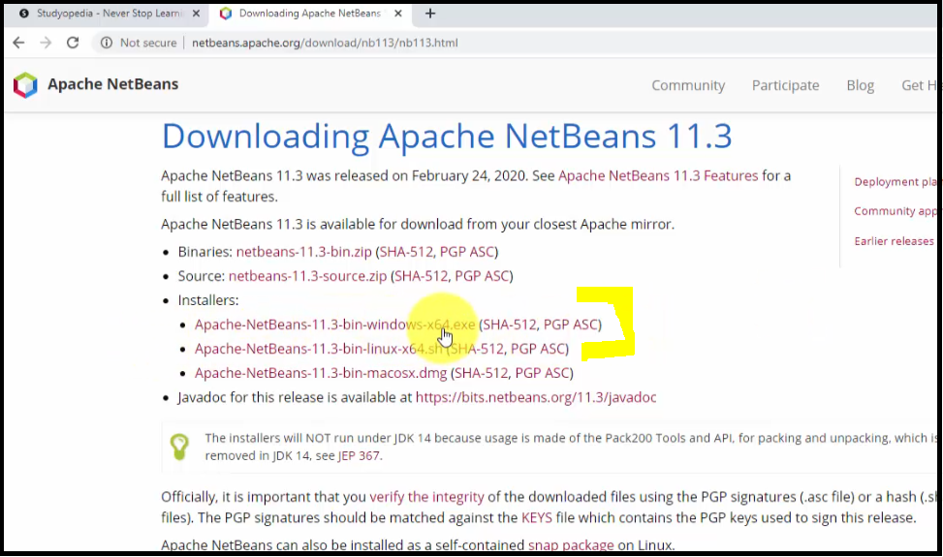

Now, you will be redirected to mirror sites. Click on any of them to download NetBeans IDE. We click the first one and the Download started as in the below screenshot. The Download status would be visible on the bottom left of Chrome web browser. When the download ends, right click to reach the folder where it installed. We have set the default for Google Chrome downloads to the **“Downloads”** folder:

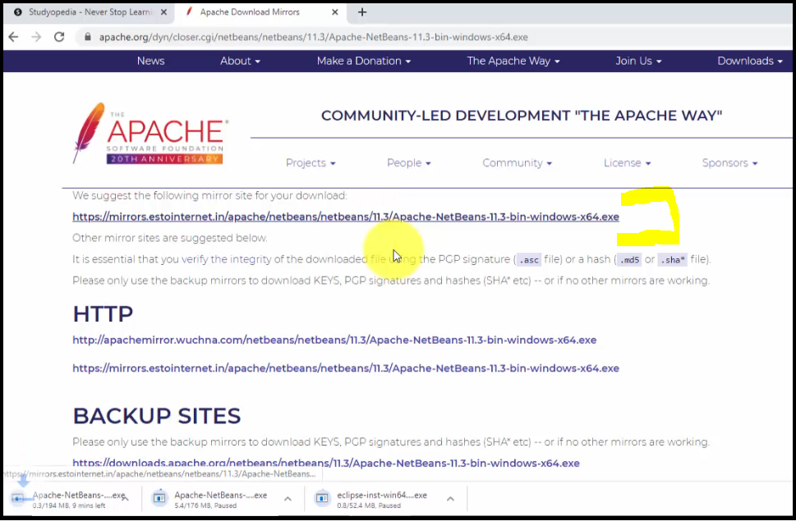

NetBeans installed successfully under **“Downloads”** folder through Google Chrome as in the below screenshot. Locate the exe file of NetBeans: **“Apache-NetBeans-11.3-bin-windows-x64”** file:

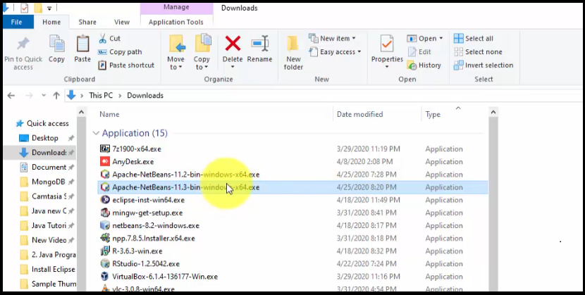

Now, let us move to Step 3 and begin installing NetBeans.

## Step 3: Installing NetBeans IDE

Now, we will be installing NetBeans IDE. Double click the exe file we downloaded in Step2 and the installation begins as in the below screenshot:

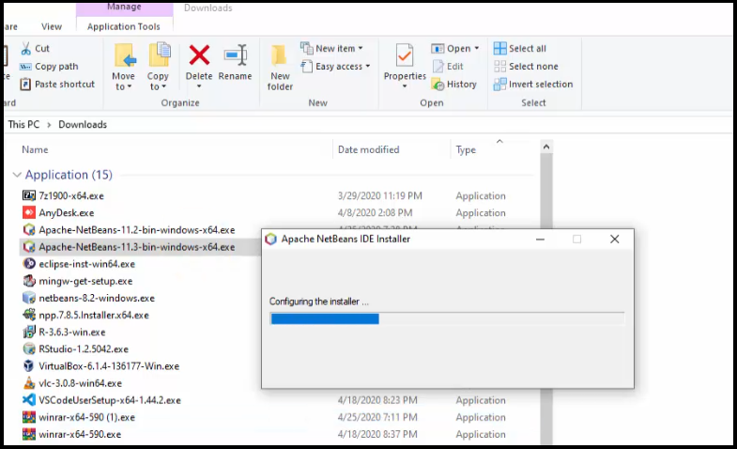

Now, you will reach the following installation dialog box (NetBeans Installer) showing what all will get installed with the installer size.

**Note**: You may get NetBeans installation error here. Do not worry, check our [tutorial to fix NetBeans installation error](https://studyopedia.com/errors-resolved/fix-netbeans-error/).

Click “**Next**” to proceed:

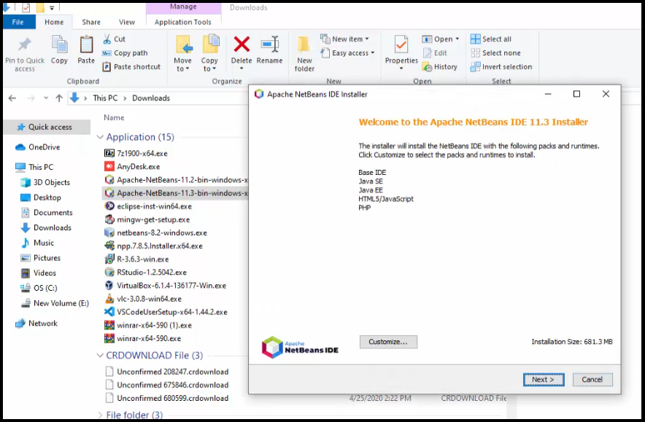

Now, let us move to Step 4 and set the path.

## Step 4: Set NetBeans and Java path

Now, set the path for NetBeans i.e. where you want to install it. We will keep the default i.e. under Program Files we will set the NetBeans path. Following is the path:

Here, you can also see we need to set the path for JAVA JDK installation. This is the reason why we need to install Java before installing NetBeans IDE. Set the same path we saw under step 1 above while Installing Java i.e. he following Java path:

Screenshot shows the same paths:

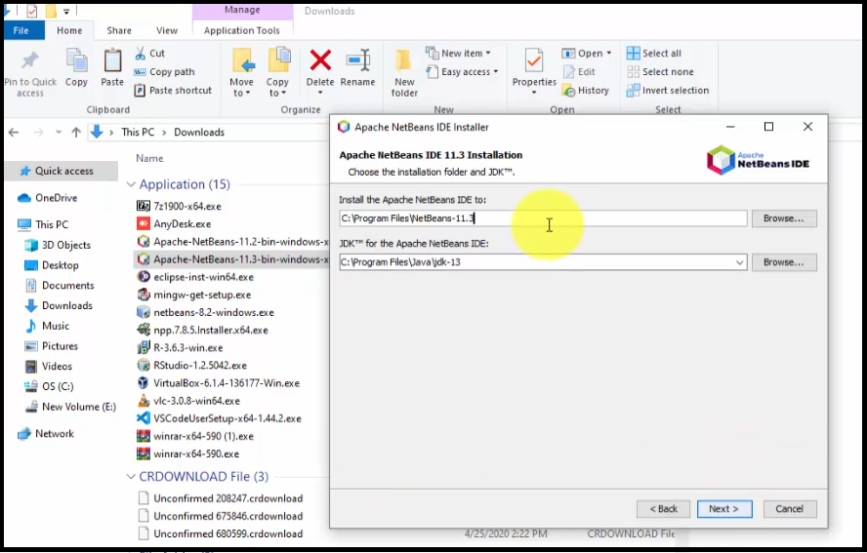

After, that click “**Next**” and the installation continues. Now, the summary of installer is visible. Click on “**Install**” as in the below screenshot:

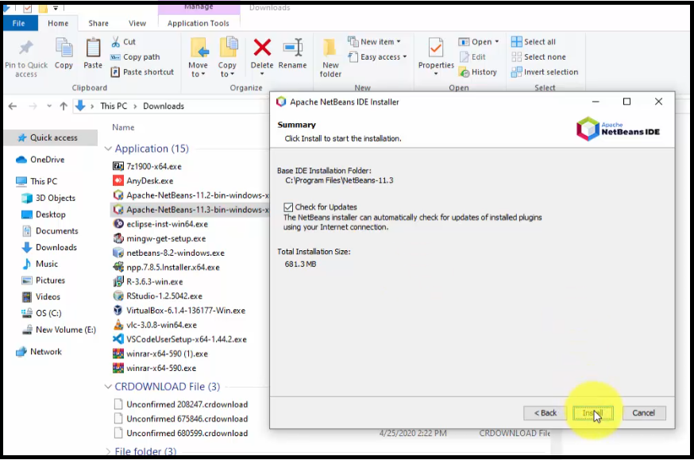

Now, installation continues. This is the final step:

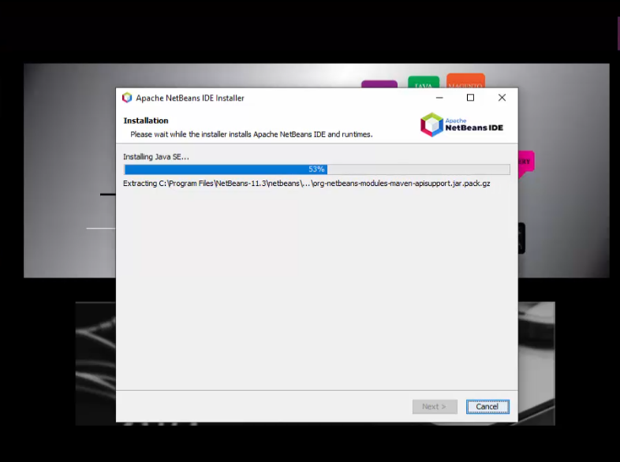

Installation completed successfully and Desktop Shortcut created as in the below screenshot:

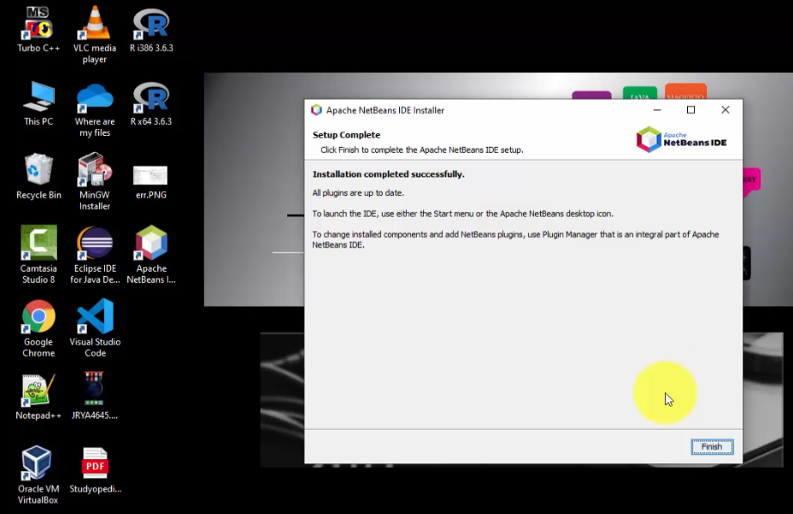

Click “**Finish**” above to close the dialog box.

## Step 5: Launch NetBeans after installation

After that, click the “**Desktop Shortcut**” to launch NetBeans as in the below screenshot:

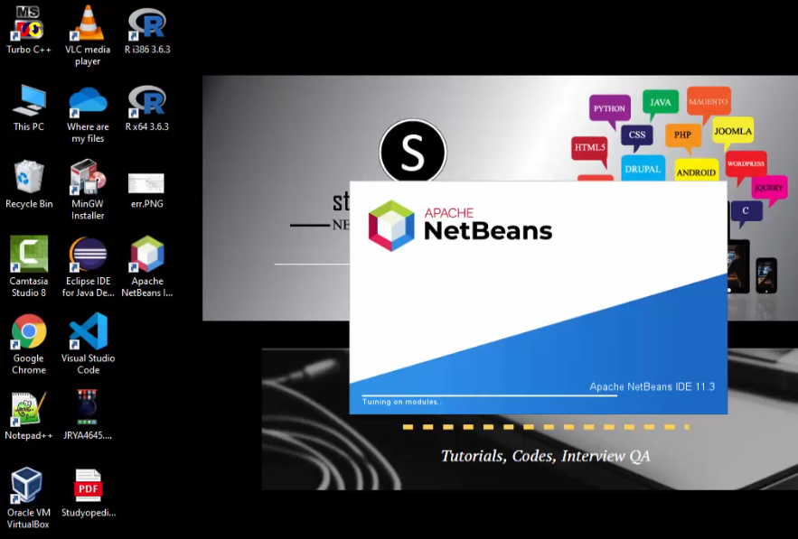

NetBeans opened successfully for the first time after installation as in the below screenshot:

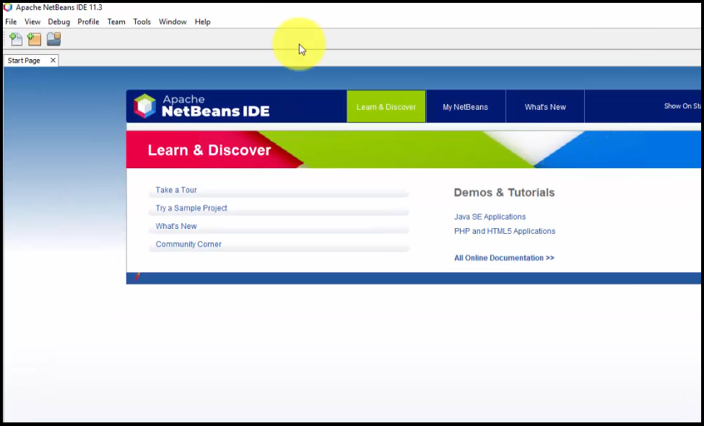

How to install MySQL database server 8.0.19

Download and install MySQL database server

You can download the MySQL community server from [this](https://dev.mysql.com/get/Downloads/MySQLInstaller/mysql-installer-community-8.0.19.0.msi) location. Once the installer has been downloaded, double-click the setup file to start the installation process. On the **Choosing a Setup Type** page, you can see four installation options.

1. **Developer default:** If you want to create a development machine, you can use this option. It installs the components which are required for application development, e.g., MySQL Server, MySQL Shell, MySQL connectors, MySQL
2. **Server Only:** If you want to create a standalone database server with specific components, you can use this option
3. **Full:** If you want to install MySQL Server with its all components, then you can use this option
4. **Custom:** If your requirements are limited to the few components, you can use this option

We are going to install MySQL Server with all components; hence, choose “**Full**” and click on **Next**.

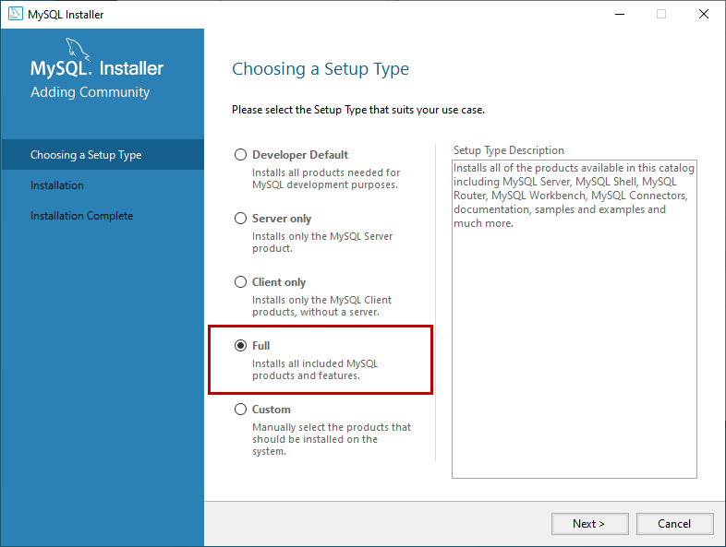

Before installation begins, the installer checks all the prerequisites that are required to install all the components of the MySQL database server. If any software prerequisites are missing, then you can see the details of failing requirements on the **“Check Requirements”** screen. It shows the name of the product, required component/software, and its status. As you can see, to install the MySQL database server for visual studio, we must install visual studio 2015 or above. Similarly, to install Python connector, we must install python on the work station. Click on **Next**.

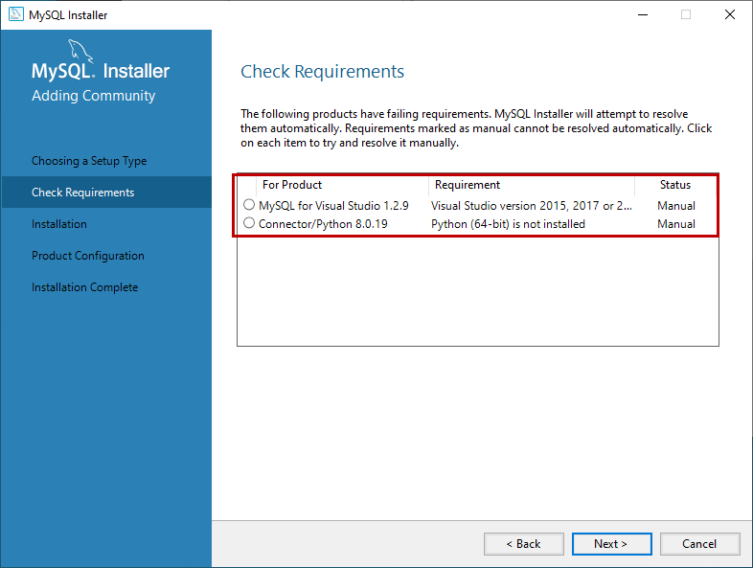

An installer gives us a warning. We can continue our installation without installing the visual studio and python. Click on **Yes**.

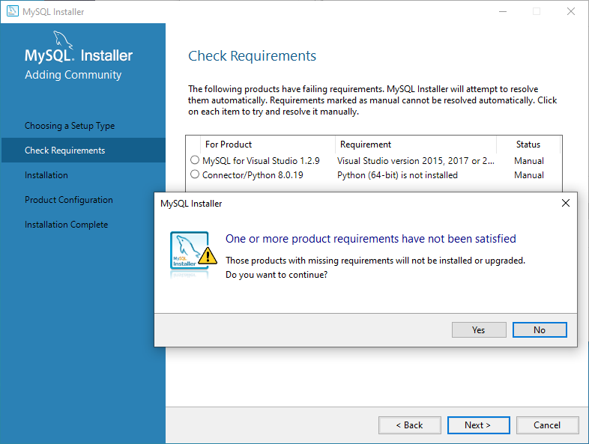

On the Installation screen, you can see the list of the MySQL products/software that are going to be installed on my workstation. Review the list and click on **Execute**.

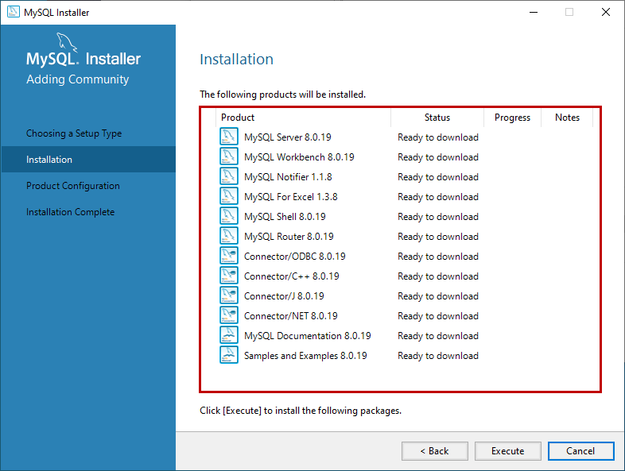

The installer downloads all the products/software. After that, it installs all the products.

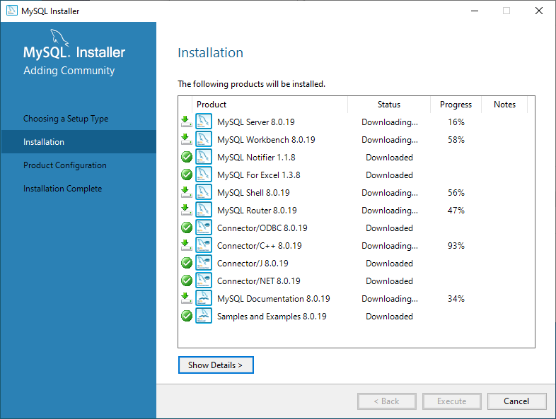

Wait for a few mins. Once the installation process completes, we are ready to configure the MySQL database server and other components. Click on **Next**.

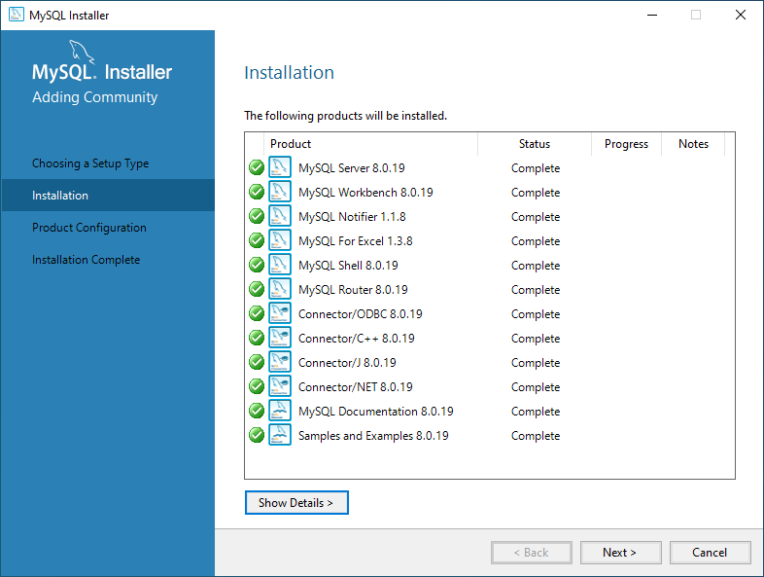

On the Product configuration screen, you can see the list of the products that need to be configured. First, let us configure the MySQL Server. Click on **Next**.

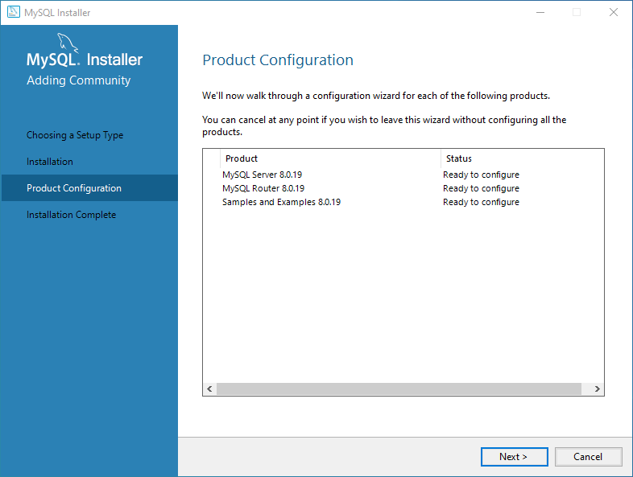

On the High availability screen, we can choose to install the **InnoDB cluster** or **Standalone MySQL Server**. **InnoDB cluster** is the High availability solution of MySQL. It uses group replication. I will explain more about it in my future series of articles. We are going to perform a standalone installation of MySQL Server hence choose “**Standalone MySQL Server / Classic MySQL Replication**”.

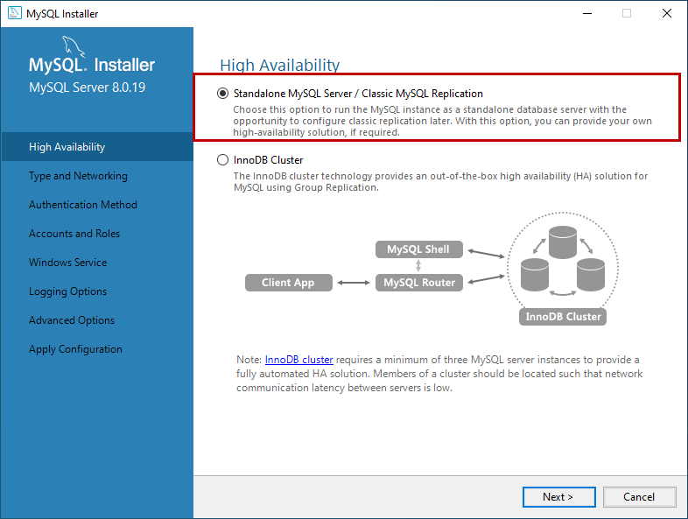

On **Type and Networking** screen, we can configure the following:

**The type of MySQL configuration.**

**The type of MySQL configuration** is a predefined set of configuration parameter that determines how much resources should be allocated to the MySQL Services. You have three configuration options:

1. **Development Computer:** This configuration uses a minimal amount of the resources to MySQL Service
2. **Server Computer:** This configuration uses a minimal amount of resources. This option is suitable when we are installing database servers and web servers on the same machine. The configuration allocates an average amount of resources to MySQL Service
3. **Dedicated Computer:** This option is used when we have created a dedicated MySQL Server. The configuration allocates a high amount of resources to MySQL Service

We would configure the server with minimal resources hence select “Development computer” from the Config Type drop-down box.

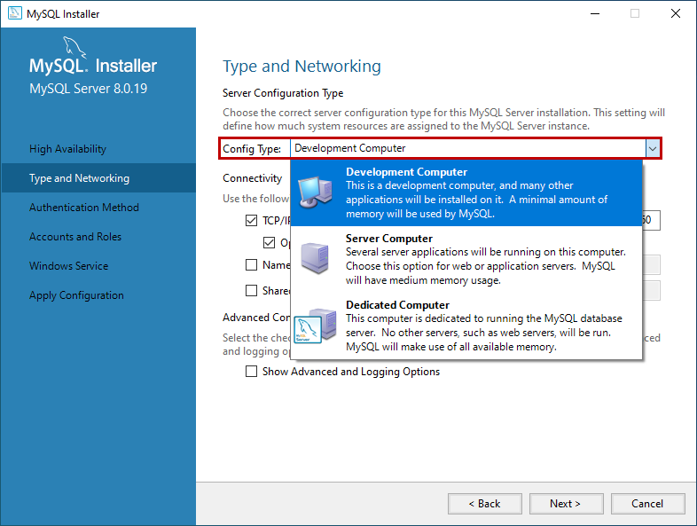

**Network Connectivity**

In this section, we can control how clients can connect to MySQL databases. We can use TCP/IP protocol or Named Pipe or Shared Memory. If you want to configure Named Pipe / Shared Memory, we must provide the Pipe Name and Memory Name. You can also specify the default port to connect to the database server. You can also choose to allow the port number specified in Port textbox in the firewall. See the following image:

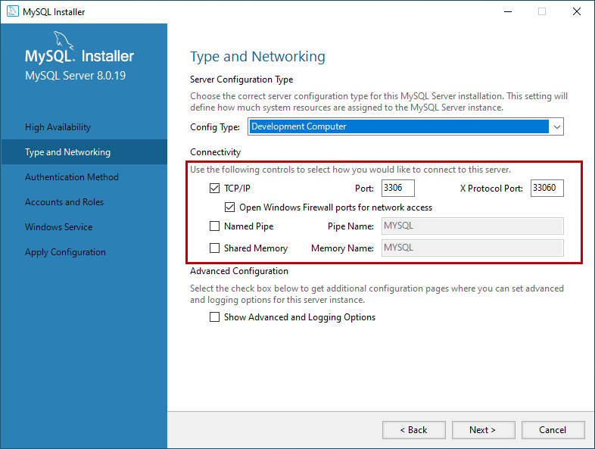

In MySQL 8.0 version, we can use SHA256 based strong passwords. On the **Authentication Method** screen, choose the option to use the Legacy authentication method or Strong password for authentication. Note: If you are using **Strong Password Encryption for Authentication,** then make sure that all the connectors must be updated to the latest version. We are going to use **Strong password Encryption for Authentication**.

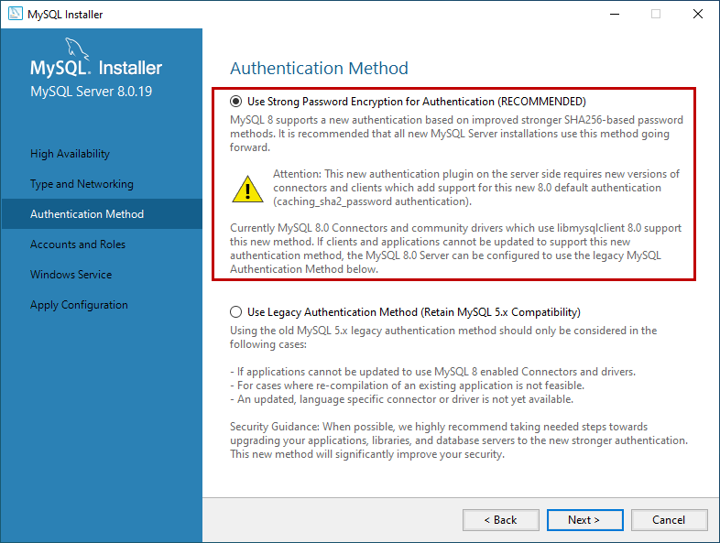

On **Accounts and Roles** screen, you can specify the MySQL root account password. MySQL Root account is a default sysadmin account, and it must be disabled.

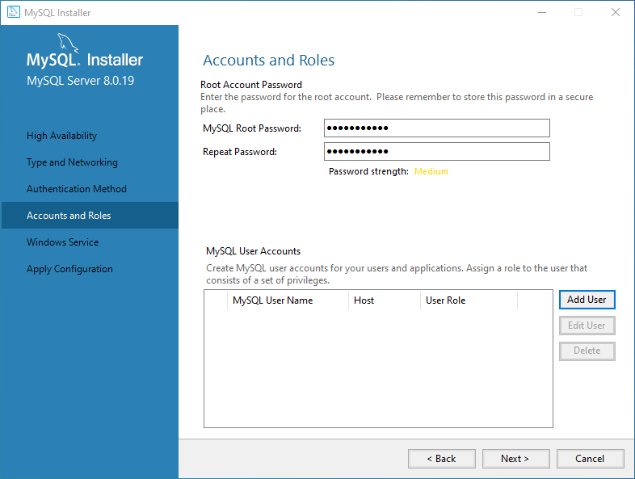

You can also create other users to do that click on Add user. On MySQL User account dialog box, provide a username, hostname, Role of the User, type of authentication, and password. Once the user is created, click on **Next**. See the following image:

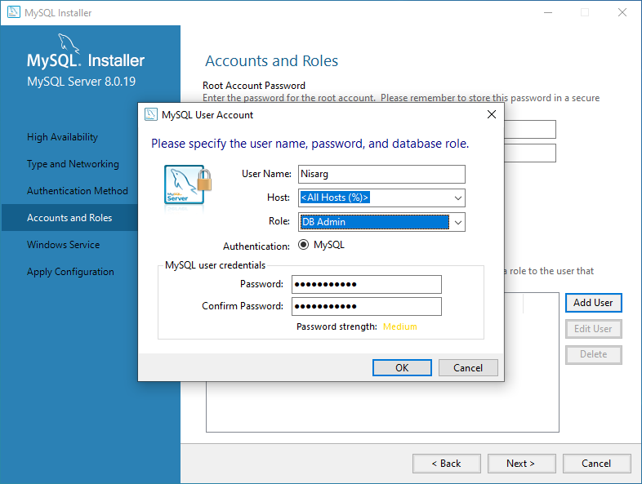

On the **Windows Service** screen, you can configure the MySQL server to run as a windows service. You can provide the desired name and configure it to auto-start the service when the system reboots. Moreover, you can provide the credentials under which the MySQL Service will run. You can choose the standard system account or provide a specific user. See the following image:

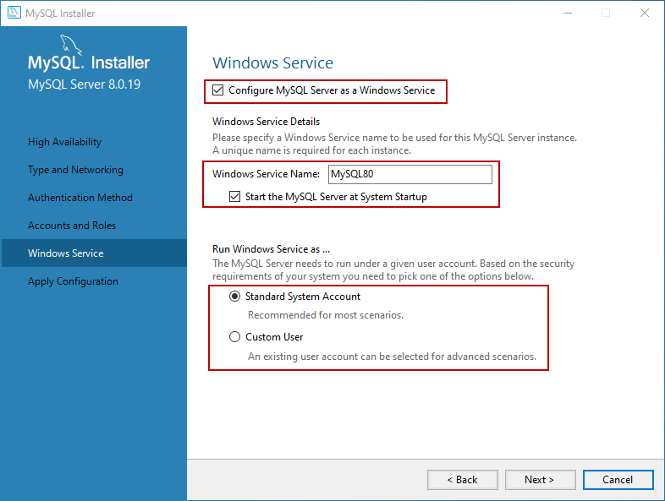

On the **Apply Configuration** screen, you can see the list of confirmation steps. Once all the configuration settings are verified, click on **Execute**.

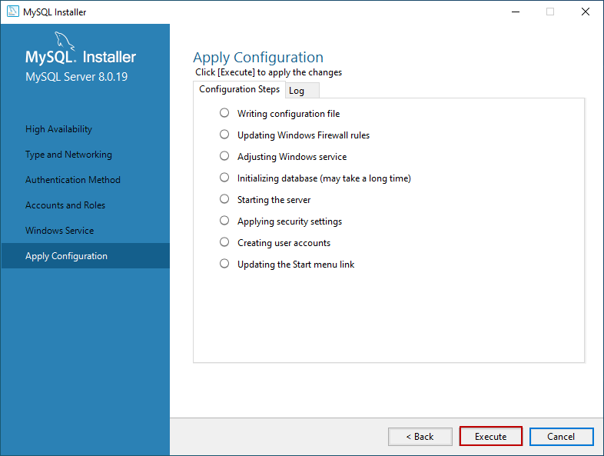

The MySQL installation process starts. You can view the installation process in the “Log” tab. Once installation completes successfully, click on “**Finish**” to close the installer.

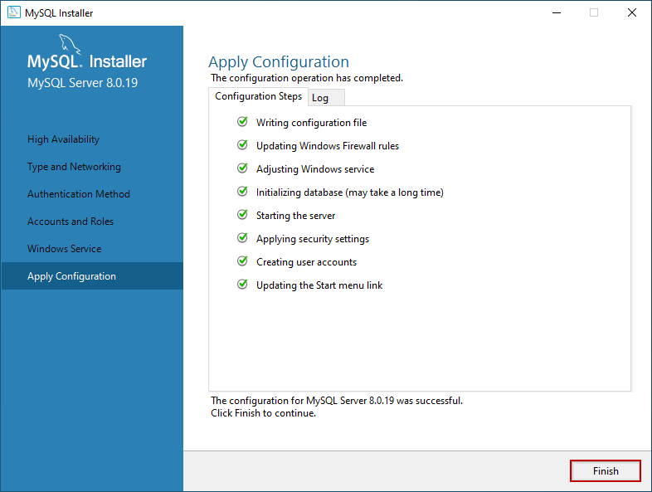

Install the sample database

If you have chosen to install all the components of MySQL Server (Full Setup Type), MySQL installer moves to Sample and Example screen. On this screen, provide username and password of the user that has root/sysadmin privileges and click on Check. If the connection establishes successfully, click on next. See the following image:

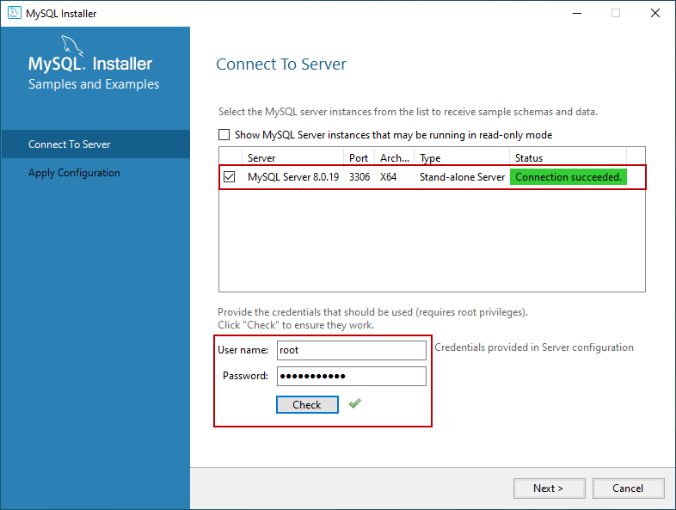

On the **Apply Configuration Screen**, click on **Execute** to start the installation of the Sample database. See the following:

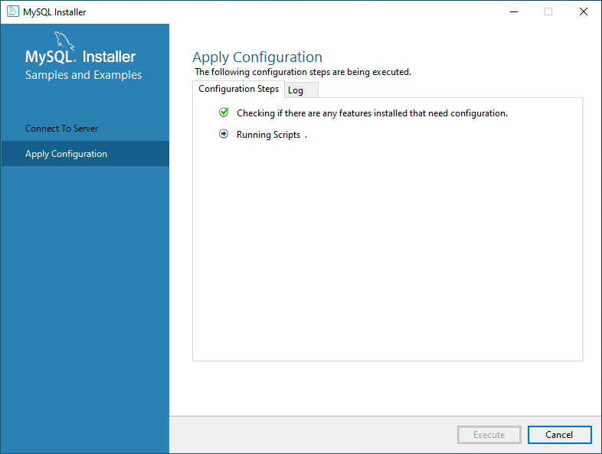

Once the sample database has been installed, click on the **Finish** button.

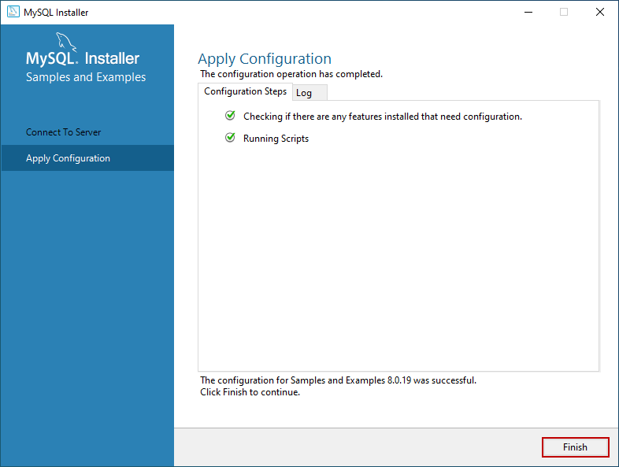

The installer continues to the **Product Configuration** screen. On this screen, you can see that the installation of the **MySQL Server 8.0.19** and **Sample and Example 8.0.19** has been completed successfully. See the following image:

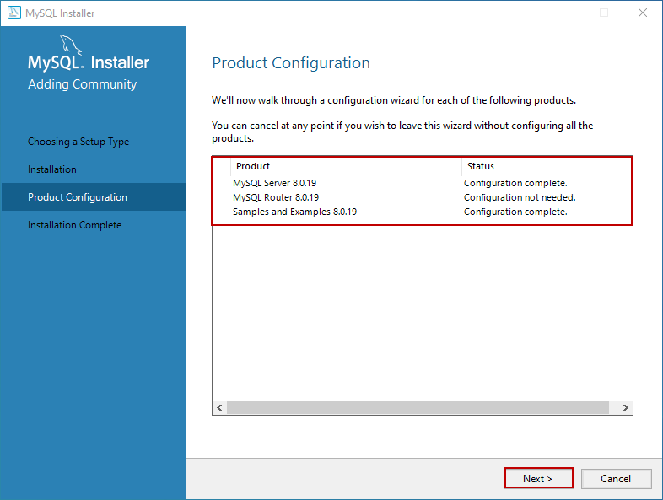

Once the installation completes, you can copy the installation logs on the clipboard to review it later. Moreover, if you want to start exploring MySQL straight away, then you can select “**Start MySQL workbench after Setup**” and “**Start MySQL Shell after Setup**” and click on **Finish**. See the following image:

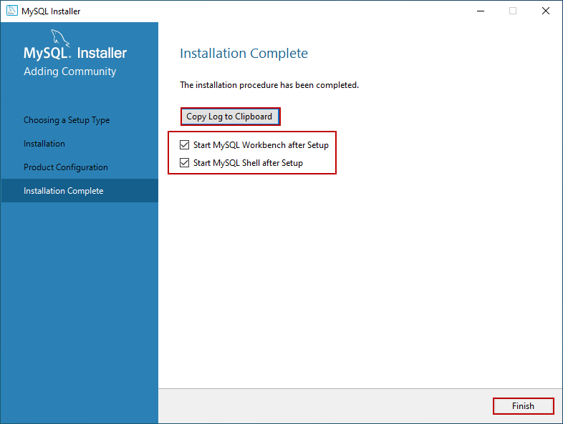

Connect to MySQL Server

Once the installation completes, let us connect to the server and execute the first MySQL Query. Open MySQL workbench. Just like SQL Server management studio, MySQL workbench is the development tool which is used to querying the database and create database objects.

On MySQL workbench welcome screen, you can see the list of MySQL connections. We have not configured multiple connections; hence you can see “**Local instance MySQL80.**” Click on it to open the new query editor window.

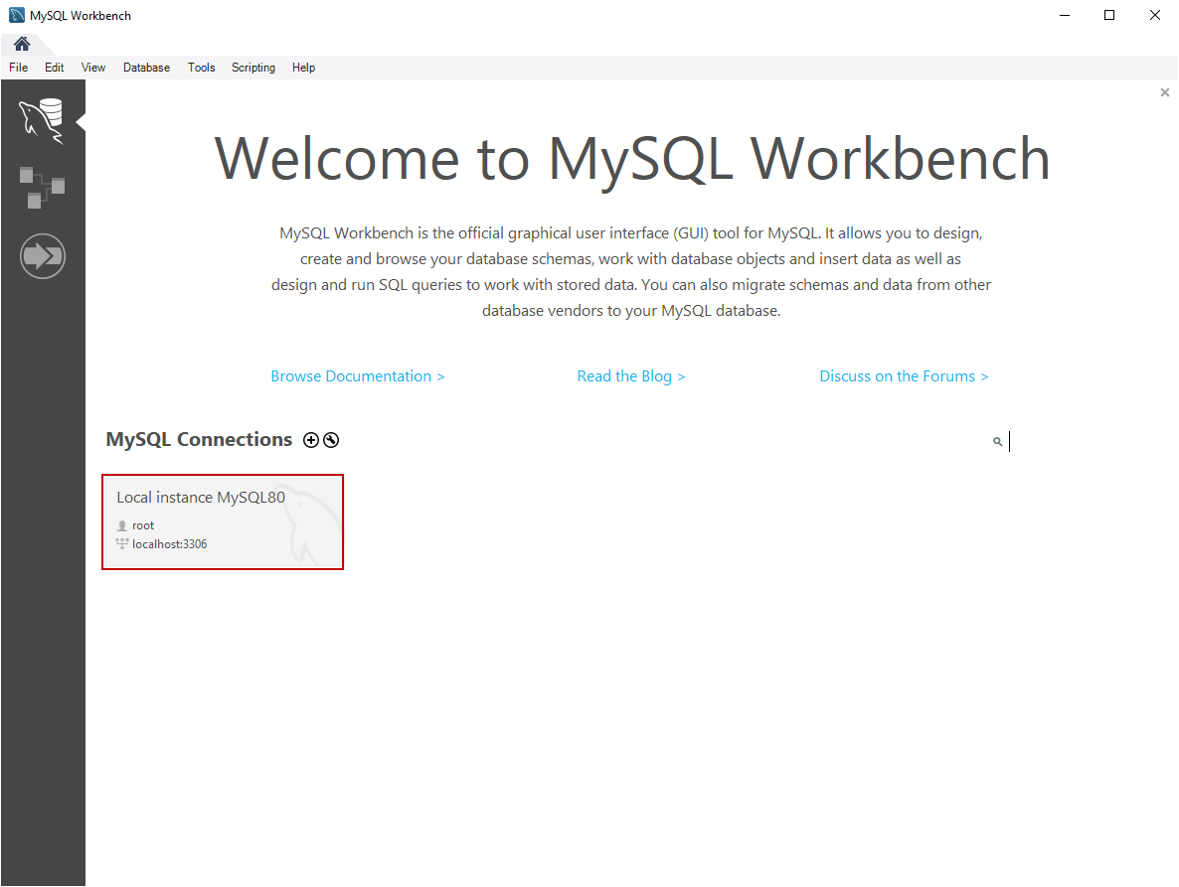

When you click on the connection, you must enter the credentials to connect the database server. Enter the password and click on **OK.**

[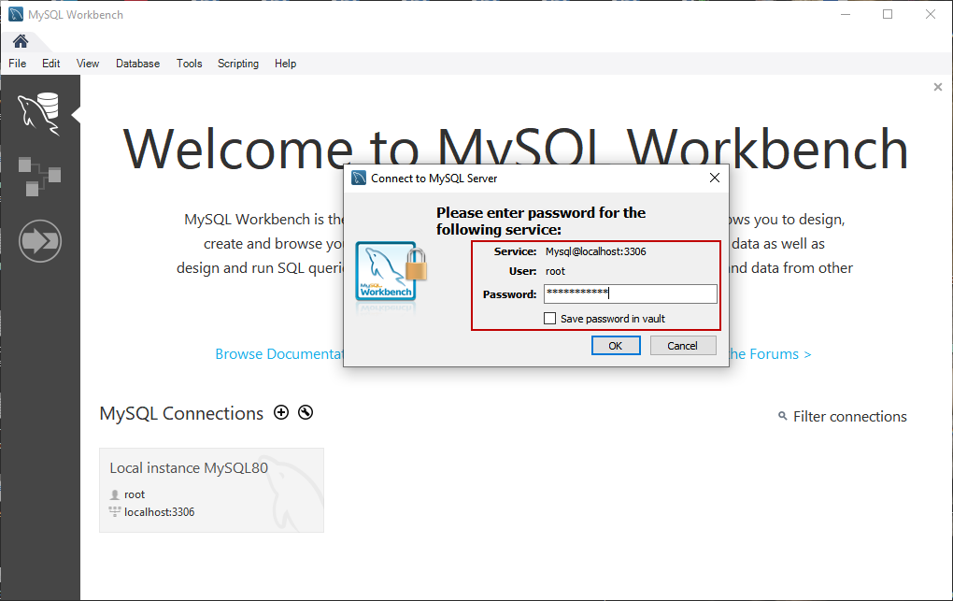](https://www.sqlshack.com/wp-content/uploads/2020/03/login-to-mysql-workbench.png)

First, let’s create a simple database on MySQL Server. Write the following query in the query editor window and click on execute. See the following image:

|  |  |
| --- | --- |
| 1 | Create database Demodatabase |

[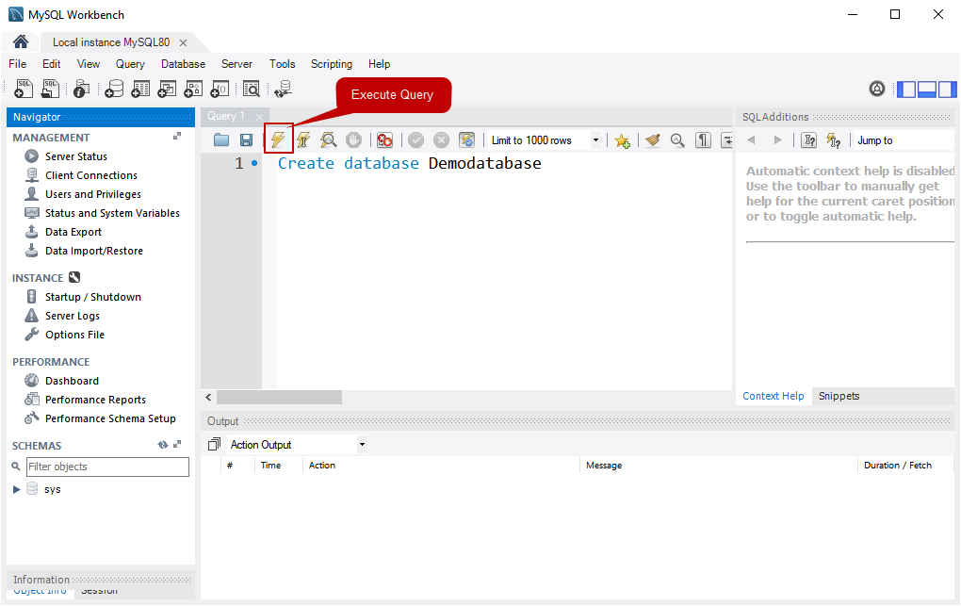](https://www.sqlshack.com/wp-content/uploads/2020/03/query-editor-window.png)

Once the query executes successfully, you can see the new database in the “SCHEMAS” pan. See the following image:

[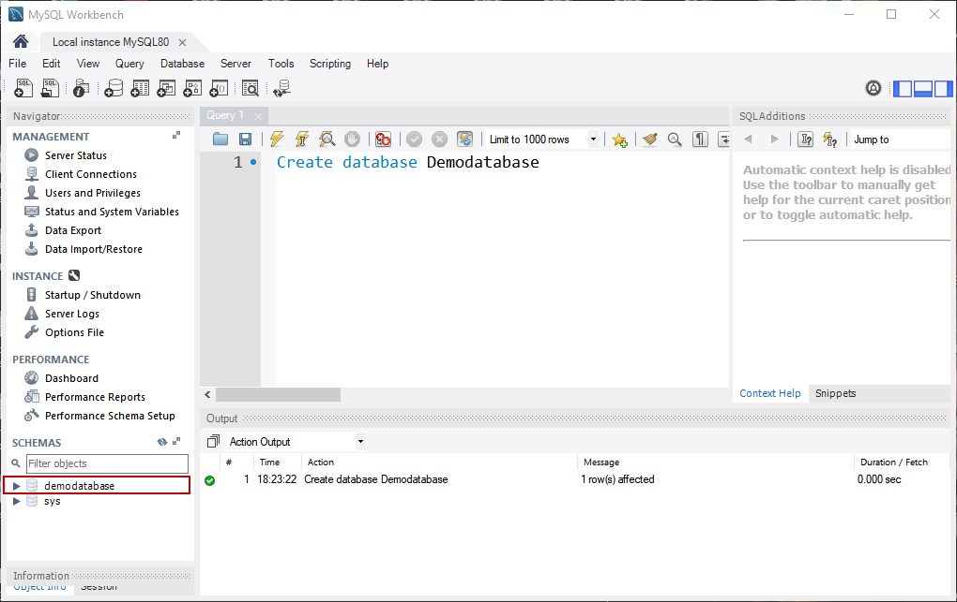](https://www.sqlshack.com/wp-content/uploads/2020/03/database-has-been-created.png)

**HOW TO IMPORT THE SQL FILE INTO Mysql workbench**

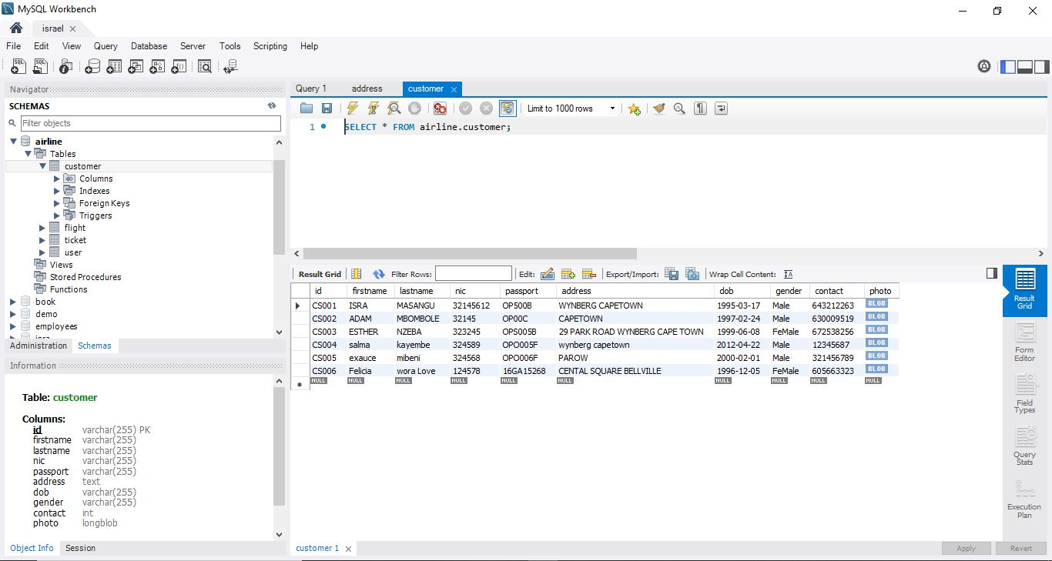

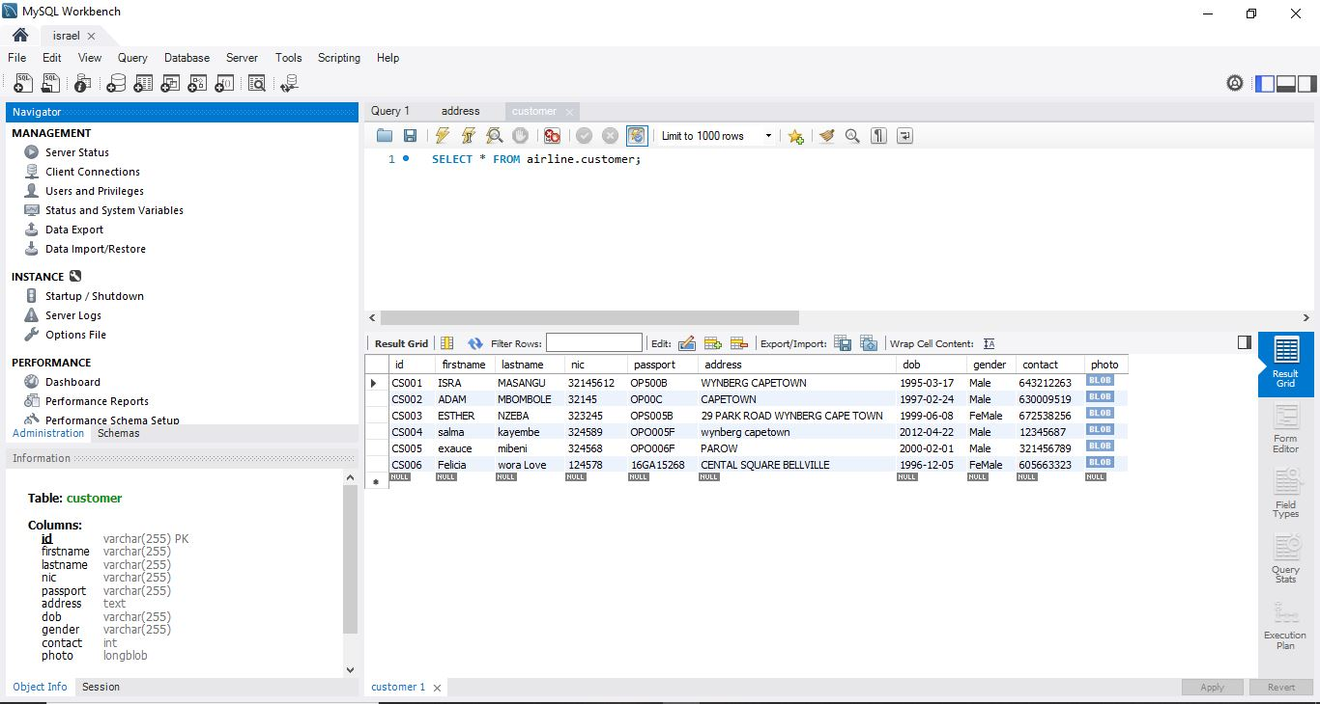

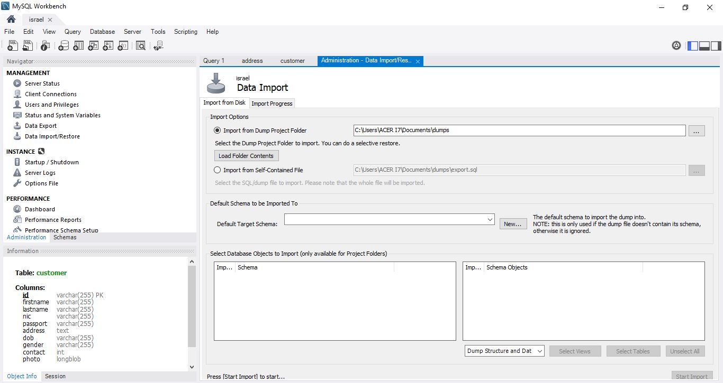

**USE THE FOLLOWING METHOD TO IMPORT THE ZIPED PROJECT TO NETBEAN**

**HOW TO IMPORT A PROJECT IN NETBEANS**

1. **Locate the zip file. In my case, it is saved on the desktop.**
2. **Open NetBeans IDE**

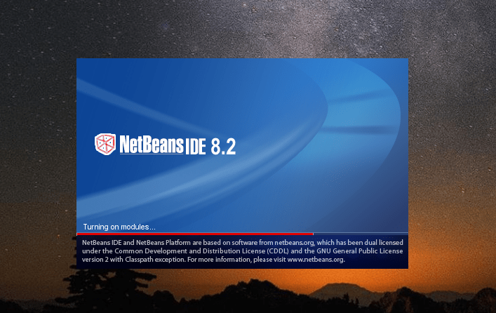

1. **Click “File”, then “Import Project”, then select “From ZIP…”**

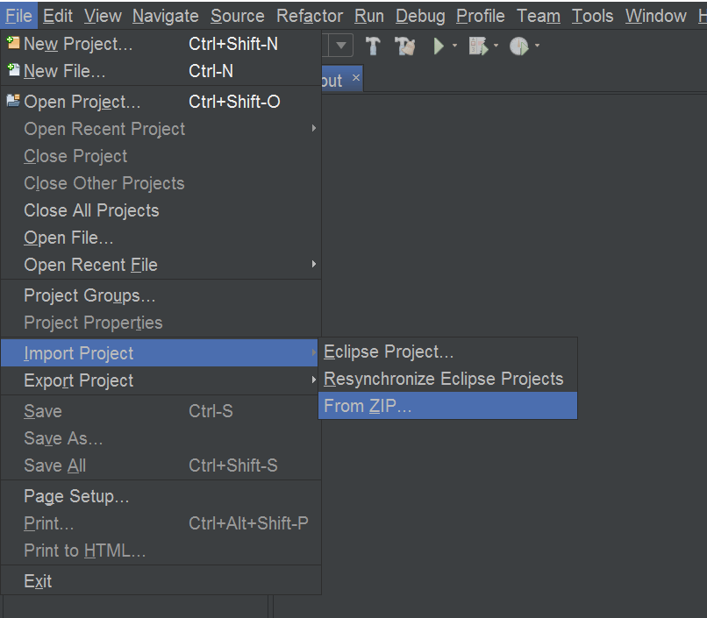

1. **Click “Browse” and lookup your zip file. Once you find your file, select it and click “Open”.**

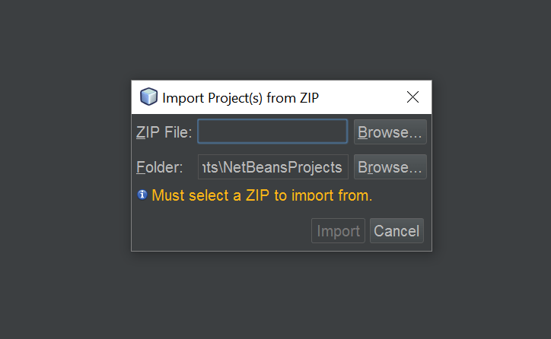

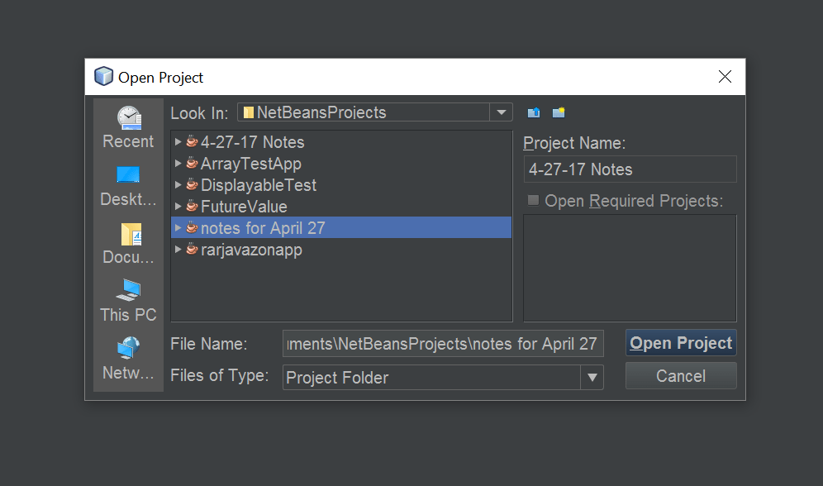

1. **You may get a message saying, “No NetBeans projects added”, but that’s not a problem.**

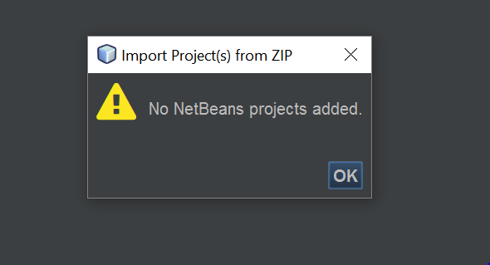

1. **Click “File”, then click “Open Project”**

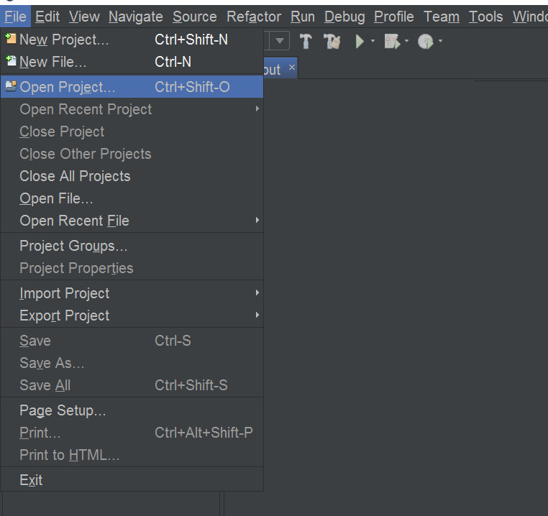

1. **Your imported project should appear in your NetBeans Projects folder. Select it and click “Open Folder”.**



1. **You should now see your imported project on your project list in NetBeans.**

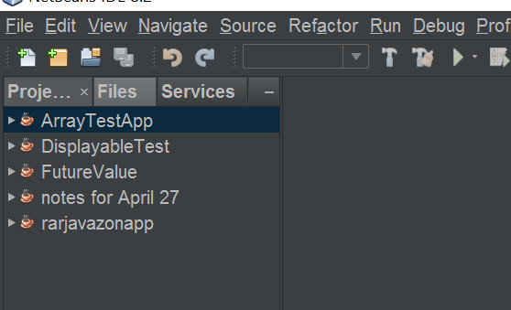

After importing the file run a jar file named Airline_Reservation_System find in the file named dist

